Capstone Project Report
Comprehensive SOC Incident Response Simulation
Project Information
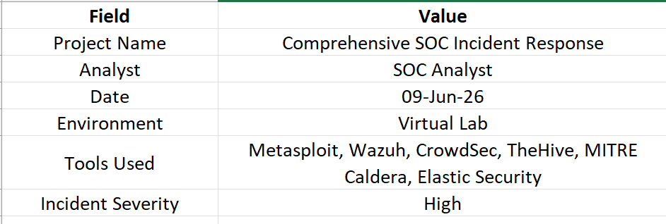
Executive Summary
This capstone project simulated a complete cyber attack lifecycle to evaluate the effectiveness of Security Operations Center (SOC) detection, response, containment, and reporting procedures.
The exercise involved exploiting a vulnerable system using Metasploit, generating security alerts through Wazuh, performing incident triage using TheHive, blocking malicious activity with CrowdSec, validating detections through MITRE Caldera adversary emulation, and analyzing SOC performance metrics within Elastic Security.
The simulated attack was successfully detected, investigated, contained, and documented. Post-incident analysis identified improvement opportunities related to automation and response efficiency. The exercise demonstrated the effectiveness of layered security monitoring and coordinated incident response operations.

Project Objectives
- Simulate a realistic cyber attack.
- Detect malicious activity using SIEM monitoring.
- Investigate alerts through SOC workflows.
- Contain threats using automated controls.
- Perform post-incident analysis.
- Measure SOC performance metrics.
- Produce executive-level reporting.

Lab Environment
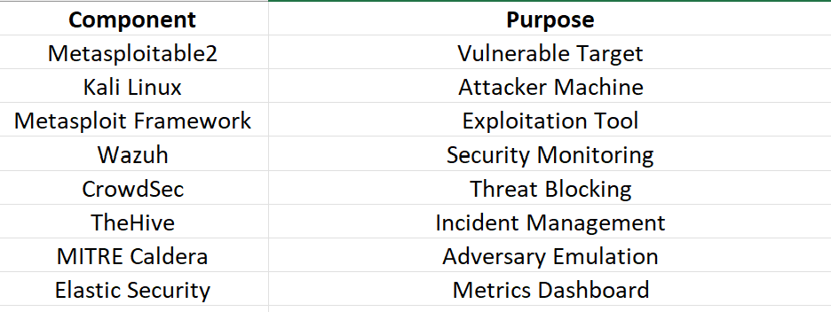
Attack Simulation
Exploitation Activity
A vulnerable Samba service running on Metasploitable2 was targeted using Metasploit.
Attack Module:
use exploit/multi/samba/usermap_script
The attacker successfully exploited the vulnerable service and gained unauthorized access to the target system.

Detection Phase
Wazuh detected suspicious activity generated by the exploitation attempt and created security alerts.
Detection Log
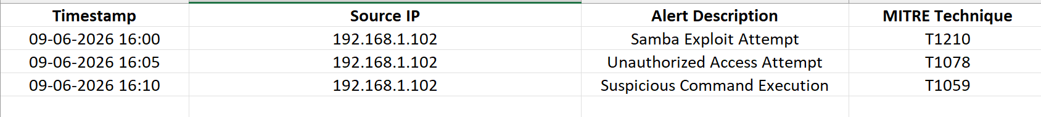
Alert Triage
The generated alerts were reviewed and prioritized according to severity.
Triage Results

TheHive was used to create and manage incident cases throughout the investigation process.

Incident Response and Containment
Following investigation, response actions were executed.
Containment Actions
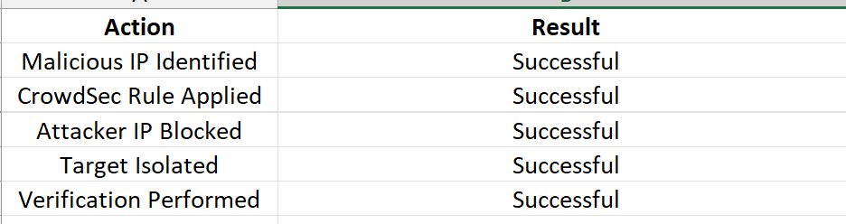
The malicious IP address was successfully blocked and communication attempts were terminated.

SOAR Automation
A response playbook was configured to automate incident handling.
Automated Workflow
Alert Generated
↓
Extract IP Address
↓
Check Reputation
↓
Block Malicious IP
↓
Create TheHive Case
↓
Notify Analyst
↓
Document Actions
Automation significantly reduced analyst workload and improved response consistency.

Adversary Emulation Validation
MITRE Caldera was used to emulate attacker techniques related to exploitation and post-compromise activity.
Emulation Results
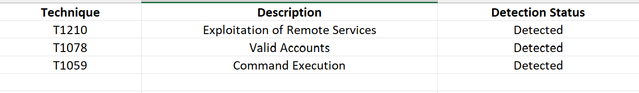Detection controls successfully identified all simulated attack stages.

Post-Incident Analysis
Root Cause Analysis
The primary cause of the incident was the presence of an unpatched Samba service vulnerable to known exploitation techniques.
Five Whys Summary
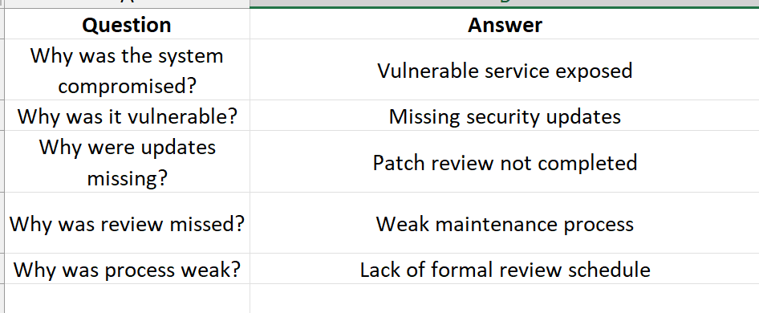
Security Metrics
SOC Performance
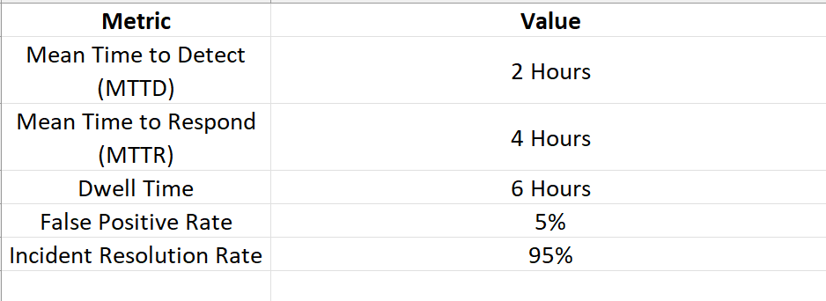
Performance metrics indicated effective detection and response capabilities throughout the exercise.

Lessons Learned
- Continuous monitoring significantly improves visibility.
- Automated response reduces containment time.
- Threat intelligence enhances investigation accuracy.
- Regular patch management is critical.
- Adversary emulation validates defensive effectiveness.

Recommendations
Immediate Actions
- Patch vulnerable services.
- Review exposed systems.
- Strengthen monitoring rules.
Medium-Term Improvements
- Expand SOAR automation.
- Increase threat intelligence coverage.
- Improve asset management procedures.
Long-Term Improvements
- Conduct regular red-team exercises.
- Perform quarterly adversary emulation assessments.
- Implement continuous vulnerability management.

Conclusion
The capstone project successfully demonstrated the complete Security Operations Center incident response lifecycle, including attack simulation, detection, investigation, containment, adversary emulation, post-incident analysis, and executive reporting. Security controls performed effectively, and all major attack stages were detected and documented. The exercise validated the organization's monitoring capabilities while highlighting opportunities for process improvement, automation enhancement, and proactive threat management.

